From : OC IA Gp | To : All HKACC members
Email : twcfranky@gmail.com | cc : HQ
Ref : | Date : 2 Sep 2015

HKACC Aircraft Engineering Workshop
Sheet Metal Basic Course
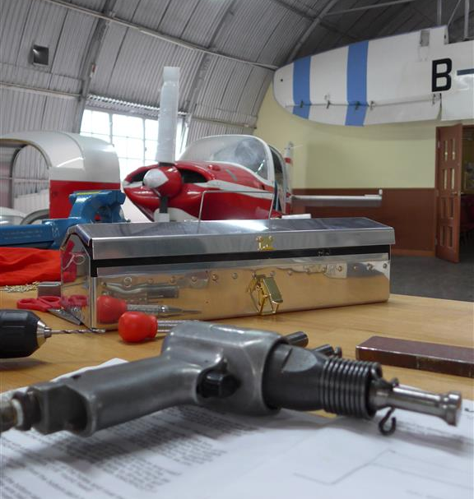
The 8-day Sheet Metal Basic Course is organised by HKACC Aircraft Engineering Workshop. Our goal is to present the basics of sheet metal applications and to give you a solid understanding of airplane construction.
Course Date: | 2015 - 25 Oct , 22 Nov, 20 Dec  2016 - 24 Jan, 28 Feb, 20 Mar, 24 Apr, 22 May  Once meeting per month (Sunday)
Time: | 1000-1700
Venue: | HKACC Aircraft Engineering Workshop at Nissan Hub / HK Aviation Club
Age: | 14 and above (for both cadet /adult members)
Class size: | Limited to 8 students to insure individualized instruction (priority will be given to cadet members & committed to attend all 8 lessons)
Course fee: | HK$400ea (includes all training kit materials, personal protection equipment i.e. goggle, earmuff and apron)
Dress Code: | SQN /Wing T-shirt and safety shoe/boots
Instructor: | Qualified Aircraft Maintenance Sheet Metal Engineer
Course Content: | - Different designations of aluminum and their applications.  - Rivet identification.  - Layout, drill, deburr, dimple, countersink and drive rivets technique.  - Construct a toolbox kit (Van’s Aircraft Training Kit) which will develop the skills you need for aircraft sheet metal works.

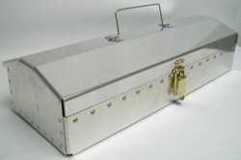

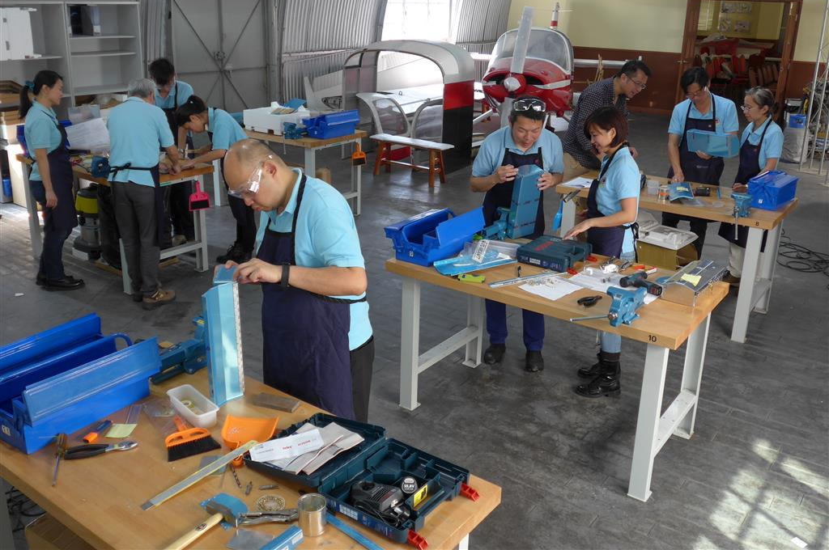
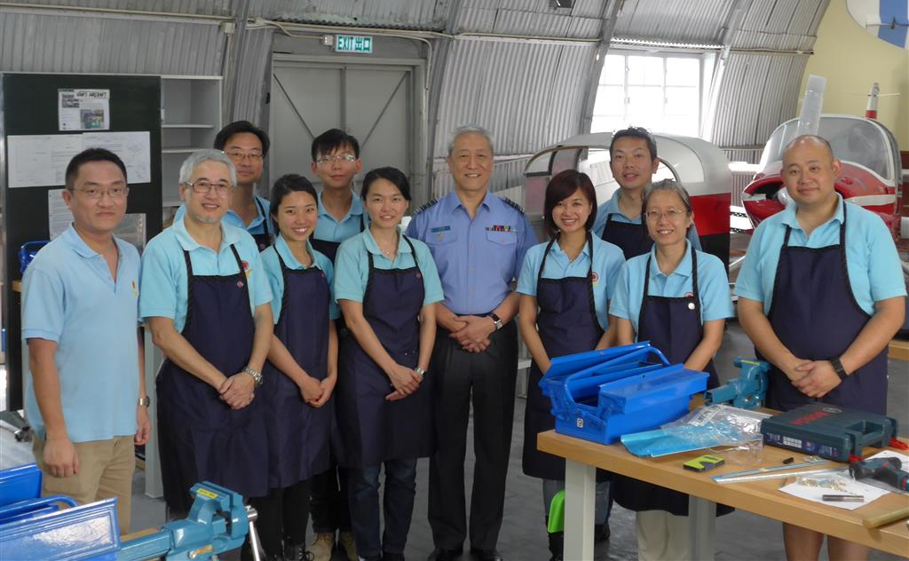

Application Procedure:
- Fill in the application form and endorsed by OC Sqn / Unit.
- Send the application to engworkshop.hkacc@gmail.com via OC Sqn /Unit by 10 Sep 2015.
- Attend the course briefing session:
  - Date & Time: 13 Sep 2015 (15:00-16:00)
  - Venue: HKACC Aircraft Engineering Workshop at Nissan Hub / HK Aviation Club
  - Dress Code: SQN /Wing T-shirt and safety shoe/boots
  - Briefing content: workshop environment familiarization and course details
- Successful applicants will be shortlisted and announced on 5 Oct 2015.
- For enquiry, please email to engworkshop.hkacc@gmail.com

Franky TSE
Squadron Leader
OC IA Gp

HKACC Aircraft Engineering Workshop
Sheet Metal Basic Course
Application Form

- Personal Information:
Rank:
Name:
Serial number:
Sqn /Unit:
Age:

- State briefly why you want to apply for the Sheet Metal Basic Course (250 words)

- OC Sqn / Unit Recommendation:
Rank:
Name:
Post:
Comment:

Signature:
Date:

